Influence Study of Aluminum Dross on Polypropylene Matrix-Polymer Composite Material Properties

Khanob Kongchatree¹, Paiboon Yaemphuan², Jesada Kaewwichit³, Waraporn Roybang⁴, Kittipong Kimapong⁵

¹K.Powder Metal Co.,Ltd. Bangkok, Thailand
^{2,3,4,5}Department of Industrial Engineering, Faculty of Engineering,
Rajamangala University of Technology Thanyaburi, Pathumthani, THAILAND.
Email: kpowdermetal@hotmail.com¹, paiboon.y@en.rmutt.ac.th², jesada.t@hotmail.com³, waraporn2029@gmail.com⁴, kittipong.k@en.rmutt.ac.th⁵

ABSTRACT:
This paper is aimed to study the influence of aluminium dross from Thai aluminum casting factory on polypropylene matrix-polymer composite material properties. The summarized experimental results are as follows. An increase in the amount of aluminum dross polymer composite material affected to increase hardness, modulus of elasticity and abrasion resistance. However, the increase of the aluminum dross had no effects to change the yield strength and the melting temperature of the polymer composite material. The aluminum dross also affected to form the crystallinity at 117-122 ºC and directly increased the rigid property of the composite materials. The microstructure examination revealed that the aluminum dross was located in a polymer matrix and affected to increase the dark colour of the polymer composite material.

Keywords: aluminium dross, polypropylene, composite, mechanical properties,

1. INTRODUCTION

Aluminum is the second largest metal in quantity that could be found on the earth and has an advantage to form various valuable products in a human life. A good advantage of the aluminum that is better than copper or steel, is aluminium has a high strength to weight ratio and is easily deformed in required shapes of the products. For the production of aluminium alloy products such as a vehicle wheels, the aluminum ore and aluminum scrap are melted in the crucible furnace at the given time and temperature for aluminium liquid. When the aluminum liquid reached the pouring temperature, some substance such as a deoxidizer or a purifier, are added to the aluminum liquid. This substance addition forms impurity that groups and floats to the surface of the aluminum liquid. The mixer of the additional substance and the impurity is called “dross” [1] and is frequently removed from the liquid surface before pouring the aluminum liquid into the moulds. This process introduces the aluminum liquid to be purified and be assured to have a good product when the aluminum liquid solidifies to be the aluminum solid product.
In Thailand, the amount of aluminum dross from the aluminum casting factory has continuously increased and dumped to the ground without any utilization. If the aluminum dross was utilized to produce the products that could apply in any work, it could have reduced the industrial waste and preserve the environment in Thailand. Therefore in this study, we aimed to prepare the composite material that had a matrix of polypropylene (PP) and had some addition of aluminum dross. The result of the aluminum dross amount of PP properties was investigated and compared.

2. EXPERIMENATAL PROCEDURE

The aluminum dross received from Thai aluminum casting factory was washed by the fresh water to remove unnecessary objects in the dross. This washing process was as follows. Firstly, the aluminum dross and the water were mixed and stirred in the container until the water color became darker. Secondly, after keeping the mixer in the container for a few minutes, the dark water was poured out of the container. This process was repeated until the water color of the mixer in the container become clear. The washed aluminum dross was dried under the sun for 4 hours and then was crushed by the ball mill crushing machine for 6 hours. The crushed Al dross was filtered by the filtering machine as shown in figure 1 to get the Al dross that was not larger than a mesh number of 200 for this experiment as shown in figure 2.

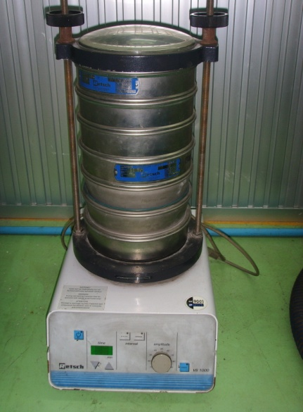 | 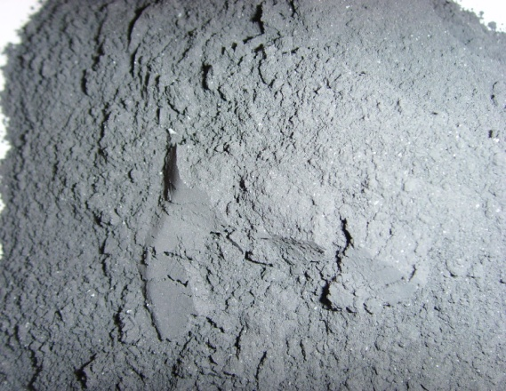
Figure 1: Particle size sieving machine. | Figure 2: Aluminium dross that was crushed, sieved and classified to be not larger than that of the 200 mesh number.

The formation of the composite products were as follows. Firstly, the Al dross was mixed with PP in an internal mixing machine at the mixing temperature of 200 ºC, at the rotating speed of 40 rpm, the mixing time of 5 minutes, and the Al dross amount of 1-9% (wt%). Secondly, the mixed composition of Al dross and PP from the internal mixer was crushed again by a plastic crushing machine and was heated in the furnace at 80 ºC for 8 hours. Thirdly, the mixed composition of Al dross and PP from the heater was formed using a thermoforming process to be a tensile test specimen that had a dimension - ASTM D638 Type IV. The thermoforming process parameter in this experiment was a temperature of 1700 ºC, a pressure of 10000 kg, the pre-heating time of 8 minutes and a pressing time of 5 minutes. After that the formed specimen was rapidly cooled on the cooling base for 5 minutes and then naturally cooled to room temperature.
A tensile strength of the forming test specimen was conducted and followed ASTM D638 [2] using a Monsanto-T2000 tensile testing machine with a load cell of 100 N and a test speed of 500 mm/min. The information during the test such as a force, a displacement, a yield strength, a modulus of elasticity and a break point elongation were recorded and analyzed. A hardness of the forming test specimen was conducted and followed ASTM D2240 [3] using a shore D hardness test machine with a loading time of 15 seconds. A thermal property of the test specimen was conducted by a differential scanning calorimetry (DSC) technique using A Perkin Elmer differential scanning calorimetric machine. A melting temperature, a crystallinity temperature and a melting enthalpy (a heat of fusion) [4] were recorded and analyzed. The microstructure of the specimen that was manually broken after immersed in liquid nitrogen was examined using JEOL scanning electron microscope with a voltage potential of 20 kV.
An abrasion test of the forming specimen was conducted by the abrasive testing machine that was constructed and followed DIN 53516 as shown in figure 3. The test specimen configuration was a cylinder shape that had a diameter of 16 mm and a length of 6 mm. The testing condition was defined as the test cycle of 400 revolutions, the test load of 20N, the rotating speed of 1 rpm, and the emery paper grit number of 600.

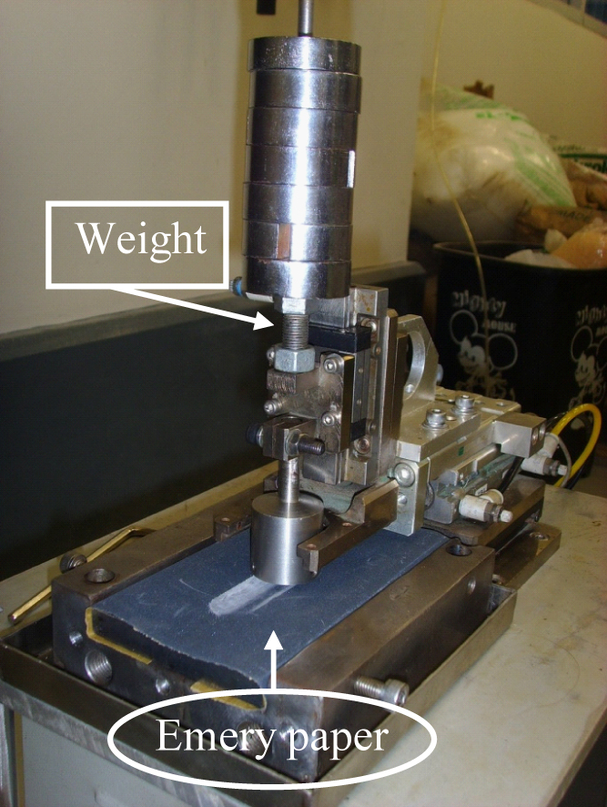 | 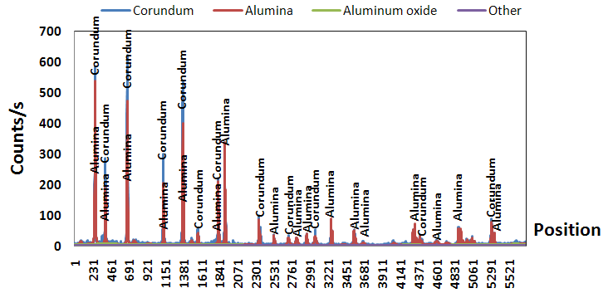
Figure 3: Abrasive test equipment. | Figure 4: XRD spectrum of aluminum dross.

3. RESULTS AND DISCUSSION

The Al dross that was classified to be not larger than that of the 200 mesh number, was filtered again by the filtering machine as shown in figure 1 and indicated the average Al dross mesh distribution of 49 microns. The X-ray diffraction analyzed result found that the Al dross was composed of 77.9% of Al₂O₃ and 22.1% of the others, such as Zn, Si, Ca, Cu, Li, etc as shown in figure 4.
Figure 5 shows SEM micrographs of the PP matrix composite fracture surfaced with various amounts of Al dross that were manually broken after immersed in liquid nitrogen. The cleavage pattern that implied the brittle fracture at the liquid nitrogen temperature was observed on the fracture surface of 100%PP as shown in figure 5. Increase of the Al dross amount in PP composite increased Al dross particle on the cleavage brittle fracture surface as shown in figure 5 (b) to (f). Size and area of the cleavage fracture were also decreased to be smaller than that of 100%PP when the Al dross amount was increased. When the amount of the Al dross was high, the fiber-like bonding at the boundary between PP and Al dross particle was observed as shown in figure 5 (c) to (f).

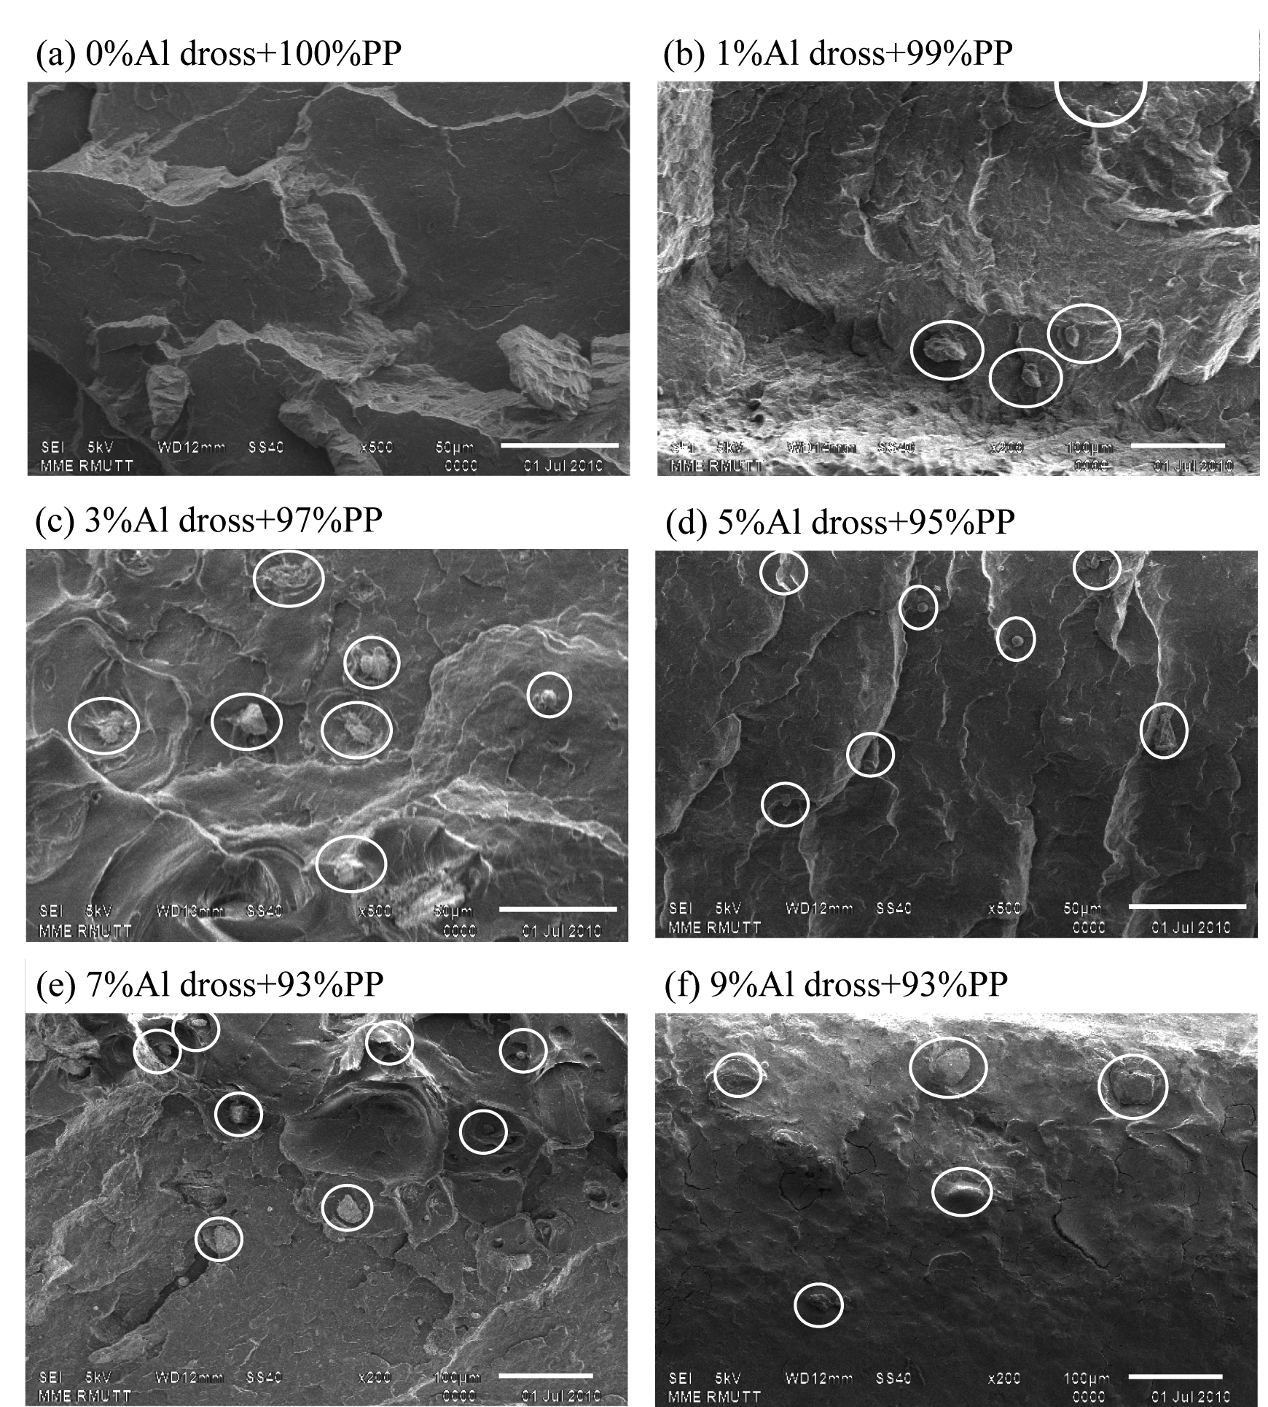

Figure 5: SEM photograph of PE matix+Al dorss.
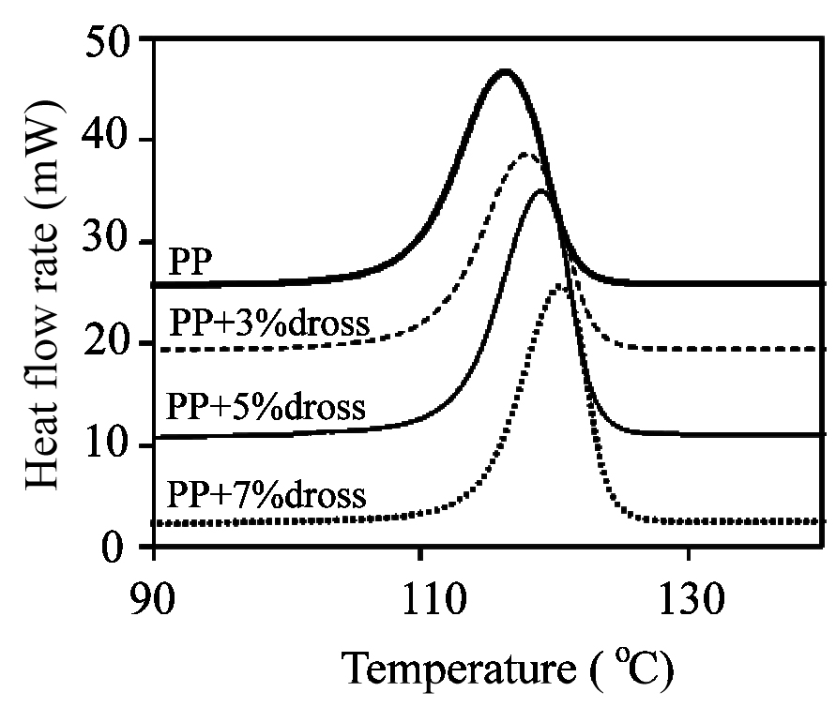
Figure 6: Relation of heat flow rate and temperature of Al dross-PP matrix composite.
Table 1: Crystallinity amount by DSC technique of PP matrix composite material.
Al dross amount (wt%) | % crystallinity
0 | 29.0
1 | 32.0
3 | 33.0
5 | 34.5
7 | 35.0
9 | 36.0

Figure 6 shows the crystallinity temperature that was obtained by DSC technique of PP matrix composite in various amounts of Al dross. The crystallinity temperature of the Al dross – PP matrix composite was higher than that of the PP as shown in figure 6. Increase of Al dross amount also increased the crystallinity temperature and increased crystallinity rate of PP matrix composite as listed in Table 1. Increase of the crystallinity temperature when the Al dross amount was increased, decreased the injection processing time. The colour of the PP matrix composite was also darker when the Al dross amount was increased as shown in figure 7.

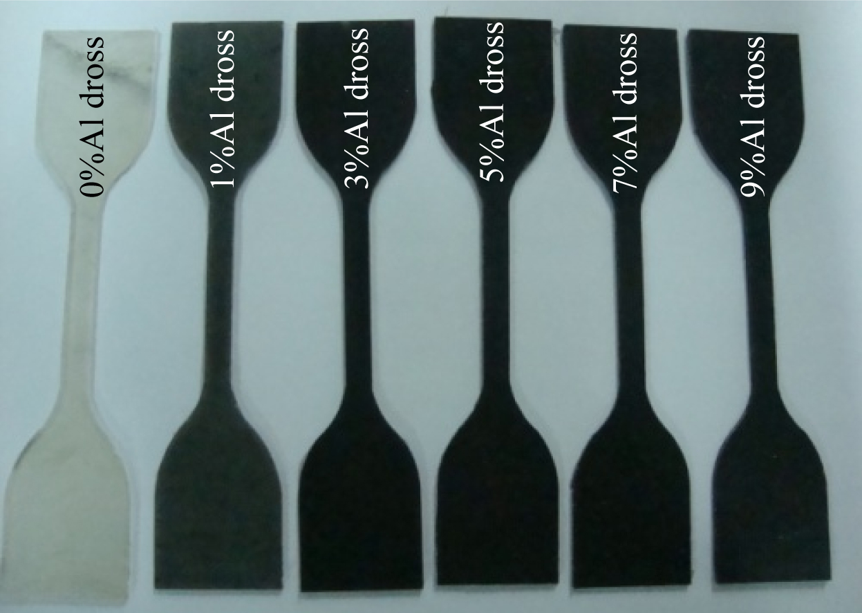

Figure 7: Tensile strength specimen follows ASTM D638 Type IV.

Figure 8 (a) shows the relation between the yield strength and the PP matrix composite at various amounts of the Al dross. The yield strength of the tensile specimen tended to be decreased from 36 to 33 MPa when the Al dross amount was increased from 1-9%. However, the increase of the Al dross amount affected the decrease of elongation of the PP matrix composite as shown in figure 8 (b). This was because of the point that Al dross embedded in the PP matrix seemed to show the high stress concentration of the specimen and decreased the specimen elongation. The modulus of elasticity that was the ratio between the yield strength and elongation was increased [5] from 410 to 560 MPa when the Al dross amount was increased as shown in figure 8 (c). The shore D hardness test result indicated that the hardness of the PP matrix composite increased when the Al dross amount was increased as shown in figure 8 (c). The increase of the specimen hardness in this study was because of the increase of the Al dross phases on PP matrix composite that was a harder.
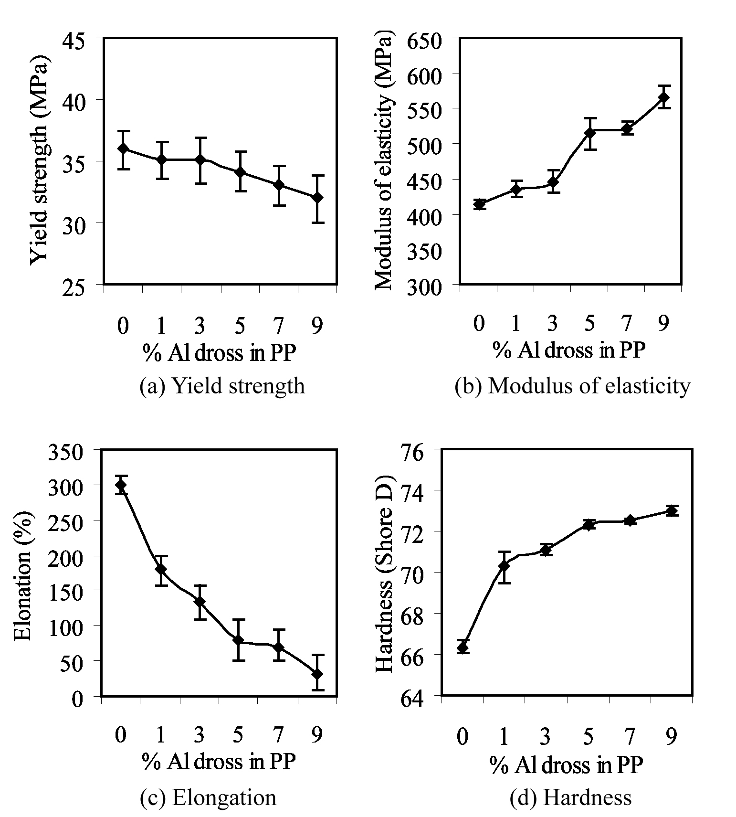

Figure 8: Relation of mechanical properties and % Al dross in PP.

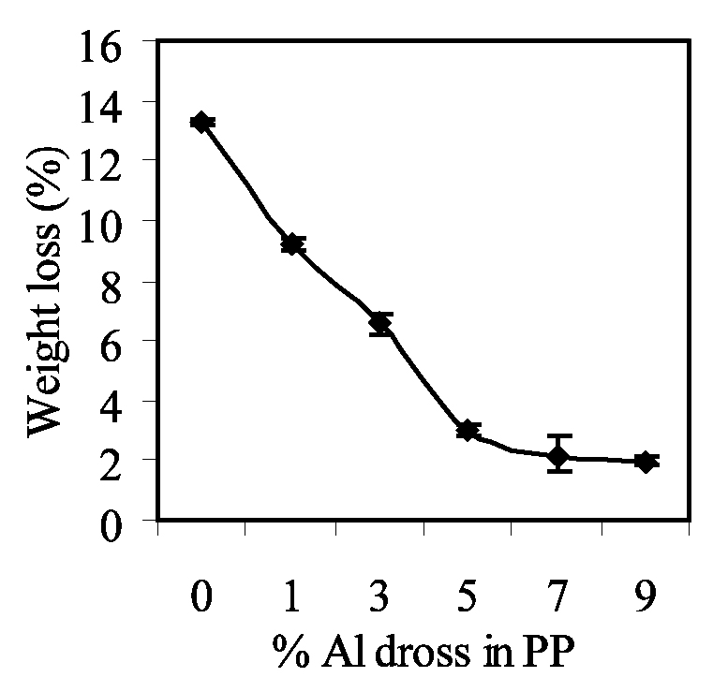
Figure 9: Relation of a weight loss and % Al dross in PP.

Figure 9 shows the relation of the Al dross amount in PP matrix composite and the % weight loss of the specimen that was tested by the a abrasion test machine as shown in figure 3. The increase of the specimen hardness when the Al dross amount was increased directly affected directly the decrease in weight loss of the PP matrix composite. The amount of weight loss of PP matrix composite specimen could decrease from 12 to 2% [6] when the small amount of the Al dross was added.

4. CONCLUSION

  - An increase in the amount of aluminum dross polymer composite material affected to increase hardness, modulus of elasticity and abrasive resistance.
  - The increase of the aluminum dross had no effects to change the yield strength and the melting temperature of the polymer composite material.
  - The aluminum dross also affected to form the crystallinity at 117-122º C and directly increase the rigid property of the composite materials.
  - The microstructure examination revealed that the aluminum dross embedded in a polymer matrix and affected to increase the dark color of the polymer composite material.

REFERENCES

[1] Chaowalit Limmaneevichitr. 2006. Cleaning of aluminum melting metal for casting. Department of Industrail Engineering Faculty of Engineering King Mongkuts University of Technology Thonburi. Thailand. (in Thai)
[2] ASTM. 1996. Standard Test Method for Tensile Properties of Plastics. ASTM D 638-96.Annual Book of ASTM standards Vol.08.01. pp1-13.
[3] ASTM. 1996. Standard Test Method for Rubber Property - Durometer Hardness. ASTM D 2240-00. Annual Book of ASTM Standard Vol.09.01.pp1-8.
[4] ASM International. 2000. Properties and Selection: Nonferrous Alloys and Special Purpose Materials. ASM Handbook Volume 2. USA.
[5] Somnook Sungnoo, Jesada Wongon. 2008. Study between polyethylene fiber with aluminum foil recycled. Rajamangala University of Technology. Thailand. (In Thai)
[6] Yiqun Liu Zhongqing Fan. 2006. Application of nano powdered rubber in friction materials. Wear. Vol 261. pp 225–229.

