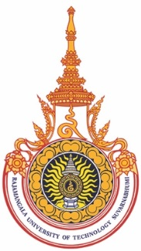
The 9th International Symposium on the Fusion of Science & Technologies and The 2nd Rajamangala University of Technology Suvarnabhumi International Conference (ISFT2022 & 2nd RUSiCON)
9

Publication Form

The ISFT2022 & 2nd RUSiCON technical committee will select high quality papers to publish in the ASEAN Journal of Management & Innovation (AJMI) e-ISSN 2351-011, or the RMUTSB Academic Journal (Science and Technology) (ISSN: 2288-9638) or RMUTSB Academic Journal (Humanities and Social Science) (ISSN: 2465-5082). Or the International Journal of Applied Computer Technology and Information (ISSN: 2773-9074). These journals are indexed by TCI (Thai-Journal Citation Index Centre).
Title:………………………………………………………………………………………………………………..
………………………………………………………………………………………………………………………..
Author:…………………………………………………………………………………………………………….
Please choose your option (only one option)
Option 1: Publish in the proceedings of ISFT2022 & 2nd RUSiCON
Option 2: Publish in the ASEAN Journal of Management & Innovation (AJMI)
Option 3: Publish in RMUTSB Academic Journal
Option 4: Publish in International Journal of Applied Computer Technology
and Information Systems (IJACTIS)
Please send this form along with the copyright transfer agreement form to ISFT2022 & 2nd RUSiCON Secretariat in Thailand at isft2022@gmail.com on the same date that you have submitted the full paper. (Deadline before 31 May 2022)
In the case that the author chose option 2, 3 or 4 and the Journal rejected your paper, your paper will be automatically published in the proceedings conference of ISFT2022 & 2nd RUSiCON.

