Development of Soil-cement in Earth-block Materials

Wiwattanachang, N¹ Maneein, N Parwong, T and Nummeesri, K

¹Rajamangala University of Technology Suvarnabhumi, Nonthaburi, Thailand,
Email: narongchaiwiwatt@gmail.com

ABSTRACT: In Thailand, the electricity consumption is very high with the intention of reduce high temperature in the building. Since 2000, a lot of people paying attention to Green-Building concept. A similar concept is natural building, which is usually on a smaller scale and tends to focus on the use of natural materials that are available locally. Therefore, the Earth-Block (EAB) product is appropriated approach to reduce energy consumption in the buildings. The EAB is produced with environmentally friendly process, which does not release harmful pollution and effective cost. The main significant character is durable materials for building construction. This study aims to develop the new thermal insulation by using soil-cement with vetiver grass fibre. Additionally, it describes the innovative systems used in production of EAB materials by mixing the soil-cement with vetiver grass fibre. This paper reveals lowest costs, space configurations changing and greater design flexibility for constructing the building.

Keywords: electricity consumption, Green-Building, Earth-Block, vetiver grass fibre, soil-cement.

- Introduction
Electric power consumption (kWh) in Thailand was last measured at 155,986,000,000 in 2011 [1]. Electric power consumption measures the production of power plants and combined heat and power plants less transmission, distribution, and transformation losses and own use by heat and power plants. The electricity consumption is very high with the intention of reduce high temperature in the building. Since 2000, a lot of people paying attention to Green-Building concept. A similar concept is natural building, which is usually on a smaller scale and tends to focus on the use of natural materials that are available locally. Ross, 1999 [2] describes methods of Green-Materials is to reduced maintenance & replacement costs over the life of the building, help in energy conservation, improve occupant health and productivity, lower costs associated with changing space configurations and gives greater design flexibility.
For the general product, Earth block is a construction material made primarily from soil. Types of earth block include compressed earth block (CEB), compressed stabilized earth block (CSEB), and stabilized earth block (SEB). CEB technology has been developed for low-cost construction, as an alternative to adobe, and with some advantages. A commercial industry has been advanced by eco-friendly contractors, manufacturers of the mechanical presses, and by cultural acceptance of the method. This study aims to develop the new thermal insulation by utilize soil-cement and vertiver grass fibre to produce the Earth-Block (EAB) product because Thailand have a lot of law materials for produce EAB and vertiver grass fibre is to advantages to improved flexural strength of earth block material.

- Application of Vetiver Grass for Construction in Thailand
Soil erosion by rain has repeatedly washed away the fertile and productive soil surface. Highland cultivation is mostly affected by these incidents even though the area is adequately supplied with rain. Some kind of barrier is needed to slow down the run off and keep water in the soil long enough for plant growth. His Majesty the King realized this problem facing the highland agriculturists. He has initiated the use of vetiver grass to alleviate different types of soil surface loss while maintaining the moisture in the soil for plant productivity. He has suggested researchers to make an in-depth study to know the potential of the Thai vetiver grass and the following conclusion was made on its characteristics and usage.
There are many research for used vetiver grass for construction in Thailand. The vetiver plant has also a few other uses, e.g. as forage for livestock, ornamentals, and miscellaneous other uses. Harvested vetiver leaves, culms and roots are utilized after some degree of processing in various ways, e.g. as input of agriculture-related activities, handicraft and art works, medicinal applications, fragrance, input of construction-related activities, containers, bouquet, energy sources, industrial products, and miscellaneous other utilization [3]. Hengsadeekul and Nimityongskul [4] of the Asian Institute of Technology, reported on the experimentation of making prefabricated vetiver-clay blocks for use as construction materials, starting with material preparation, laying vetiver-clay composite in mold, pressing process, remolding and turning face up on designed support plate, sun drying, dry heating, and block laying steps with clay slurry as wall panel. They concluded that vetiver could be used with clay composite for substituted bricks and columns for housing construction. The prefabricated wall has rather low thermal conductivity which makes it comfortable and energy saving. It is truly a labor-based appropriate technology. Nimityongskul and Hengsadeekul [5] studied the vetiver-clay composite storage bin, vetiver can be used raw material for the construction of low-cost storage bin. At Chitralada Palace in Bangkok, a grain silo made of vetiver-clay composite was piloted. The silo walls were constructed with vetiver-clay bundle, coated with cow-dung mixed with clay and rice husk, while its roof was of bamboo structure thatched with vetiver bundle overlaps. A structural component for ventilation that reduces moisture and temperature forms part of the proposed structure.
For the cement replacement material for construction, vetiver ashes have been experimentally used as low-cost, environmental-friendly, and energy-saving construction material. Nimityongskul [6] reported on the experiment of using vetiver grass ash (VGA) as a new building material specifically for the rural areas of the developing countries. Test results revealed that the silica content of VGA was approximately 7% higher and potassium oxide (K₂O) content about seven times higher than in fly ash. According to ASTM requirement VGA can be classified as class C pozzolana. VGA Mortar can be suitably adopted as a construction material for foundations, marine structures, sewers, and other chemically exposed structures. Therefore for the mix containing higher amount of cement, higher compressive strength can be expected. The slow strength gain in VGA-Portland cement mortar is probably due to the fact that the reaction of active silica with calcium hydroxide is secondary to the hydration of the main compounds namely the tricalcium silicate and dicalcium silicate. The chemical reactions of these two compounds can be written as follows:

2(3CaO•SiO₂) + 6H₂O → 3CaO•2SiO₂•3H₂O + 3Ca(OH)₂
Tricalcium Silicate + Water → Calcium Silicate Hydrate + Calcium Hydroxide
2(2CaO•SiO₂) + 4H₂O → 3CaO•2SiO₂•3H₂O + Ca(OH)₂
Dicalcium Silicate + Water → Calcium Silicate Hydrate + Calcium Hydroxide

The silica in the pozzolana reacts with the liberated calcium hydroxide to form silica gel as follows:

3Ca(OH)₂ + SiO₂ → 3CaO•2SiO₂•3H₂O
Calcium Hydroxide + Silica from pozzolana → Calcium Silicate Hydrate

- Properties of Soil-Cement
Soil-cement is a construction material, a mix of pulverized natural soil with small amount of Portland cement and water, usually processed in a tumble, compacted to high density. Hard, semi-rigid durable material is formed by hydration of the cement particles. Soil-cement mixtures differs from Portland cement concrete in the amount of paste (cement-water mixture). While in Portland cement concretes the paste coats all aggregate particles and binds them together, in soil cements the amount of cement is lower and therefore there are voids left and the result is a cement matrix with nodules of uncemented material.
Soil-cement is a simple, highly-compacted mixture of soil, Portland cement, and water. As the cement reacts, or hydrates, the mixture gains strength and improves the engineering properties of the raw soil. Its improved strength and durability, combined with its low first cost and ease of construction, make soil-cement an outstanding value for use as a base and subbase material. The major variables that control the properties and characteristics of soil-cement mixtures are the type of soil or aggregate material, the proportion of cement in the mix, the moisture conditions, and the degree of compaction. It is possible, simply by varying the cement content, to produce soil-cement that ranges from a basic modification of the compacted soil to fully-hardened soil-cement that is strong, durable, and frost resistant.

  - The Effect of Cement Content on the Compressive Strength.
When the cement content is 5-20%, unconfined compression strength of soil-cement is generally 300-3,500 kPa [7]. The relationship between 28 days unconfined compressive strength and cement content by formula below.

(1)

where, f_{cu1} is unconfined compressive strength of cement content a_{c1}, f_{cu2} is unconfined compressive strength of cement content a_{c2}

- Experimental Program
  - Preparation of Materials
The materials used to carry out research into materials that can be obtained locally
consisting of vetiver grass and clay, Portland cement type-I, coarse aggregate (crushed limestone), fine aggregate which were isolated in a manner appropriate to the production process.

    - Vetiver Grass and Soil-cement
In preparing vetiver grass and clay, only fresh vetiver grass should be used and must be dried for a month to reduce the water content to less than 8 percent, and to prevent the occurrence of insects and fungi fertilization. Figure 1 illustrated the process of vetiver grass separation membrane with sodium hydroxide. Clay used for the fabrication of soil-cement (by mixing 90% clay + 10% Portland cement) must be cohesive and must have high elasticity. It should be fine, smooth and uniform, and free from impurities such as broken tiles, roots, twigs, or organic matter is shown in Fig.2.

  - Experimental Program of Earth-Block Product
The EAB production process comprises the steps of preparing materials, quality testing of raw materials, compress process & testing and cost analysis. The experimental program is shown as follows by Fig.3.

- Results and Discussion
  - Properties of Vetiver Grass
The thermal conductivity of vetiver grass was found to be 0.045 - 0.05 W/m K which is considerably compared to conventional thermal insulation. After the sun for a period of a month, Vetiver grass has moisture in dry conditions at 8 percent to 60 percent water absorption by weight. A summary of physical properties of Vetiver’s leaves is shown in Table 1.

  - Properties of Clay
The physical properties of the clay was classified to be an inorganic clay (clay of high plasticity or fat clay, CH) as shown in Table 2. After dried, the cohesiveness of the clay is good and helps to bind vetiver grass together in wet and dry conditions.

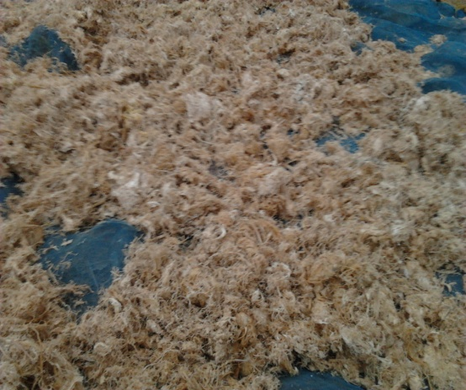
Figure 1 Vetiver Grass Fibre

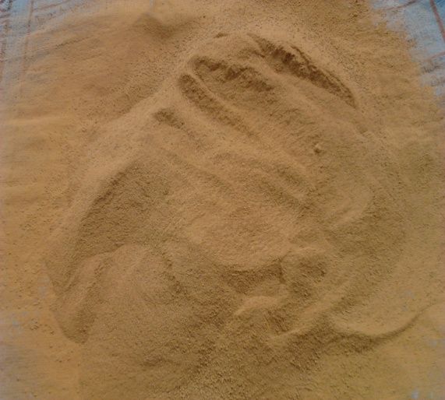
Figure 2 Clay Preparation

Figure 3 Experimental program of EAB Product

Table 1 Physical properties of Vetiver’s leaves.
Properties | Testing | Average
Physical properties | Moisture Content of Dry Conditions | 8 %
 | Water Absorption by Weight | 60 %

Table 2 Properties of Clay
Item | Description | Average
Physical Properties of CH Clay (Fat Clay) | Natural Water Content | 5 %
 | Specific Gravity | 2.80
 | Liquid Limit | 58 %
 | Plastic Limit | 29 %
 | Shrinkage Limit | 26 %
 | PH | 8

  - Properties of Earth-Block (EAB) Product
The EAB product is a construction material made from the soil-cement (90% MH clay + 10% Portland cement type-I) + vertiver grass (2% by volume) + coarse aggregate (crush limestone 3% by volume) + Fine Aggregate (3% by volume) for EAB dimension 7.5x20x40 cm for build a wide variety of structures including homes, schools, stores, barricades and fortifications. The EAB are made by compressing soil-cement and binders in a hydraulic press. These blocks can be used to build with after curing for 7 days. They reach full strength and become water resistant after a 28-day cure period.

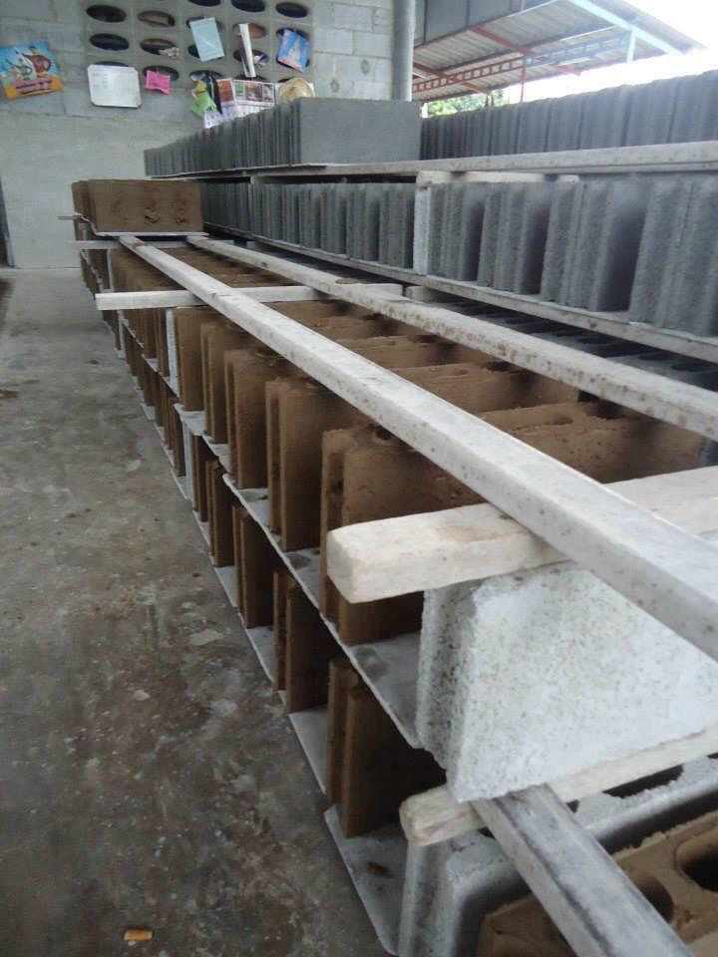
Figure 4 The EAB products with air curing

    - Compressive Strength
This test method covers the determination of the compressive strength of soil-cement using molded cylinders as test specimens (ASTM D 1633). Calculate the unit compressive strength of the specimen by dividing the maximum load by the cross-sectional area. The average axial compressive stress of all EAB was average 3.5 MPa. Vetiver grass also serves as a fiber that contributes axial compressive strength to the composite bundle. The compressive strength of EAB would be increased if the bonding between vetiver grass and soil-cement could be improved.

    - Thermal Resistance
Figure 5 shows that the difference between temperatures of EAB, cement blocks and bricks. A EAB block has thermal resistance than the brick up to 30%. Wall construction with EAB can reduce electricity consumption in the residential sector has increased steadily. The low thermal conductivity of blocks will help to prevent heat transfer into building and consequently to save energy.

Figure 5 Thermal Resistance Testing

    - Cost Estimate
Table 3 shows a comparison between the cost of producing EAB, cement block, light weight block and brick. EAB is the choice of the materials with the lowest cost compared to building materials that are available in the market. This study is shows that the construction of the house with EAB is an alternative to people who are at a lower cost.

Table 3 Comparison of price and quantity of materials used for construction.
Type of Materials | Dimension (cm) | Unit Cost (Baht) | U.Cost + Laber/m² (Baht)
EAB | 7.5×40×20 | 6 | 200
Cement Block | 7.5×40×20 | 8 | 220
Light Weight Block | 7.5×60×20 | 25 | 320
Brick | 6×14.5×3.5 | 0.80 | 280

- Conclusion
A EAB block has thermal resistance than the brick up to 30%. Wall construction with EAB can reduce electricity consumption in the residential sector has increased steadily. The optimum volume ratio of soil : cement : coarse aggregate (crush limestone) : fine aggregate (sand) and vetiver grass fibre weight (kg) is 8.5:1.5:2:2 and 0.5 kg. The average specimen properties are as follows: thermal conductivity of 0.5 W/mK, compressive strength of 3.5 MPa. EAB take very little energy to make compared to the extreme heat necessary to make cement, the firing process required to make bricks, and the deforestation required to build with wood.

- Acknowledgement
The authors would like to express their appreciation to Rajamangala University of Technology Suvarnabhumi (RUTSB) for their support and assistance throughout this project.

- References
[1]World Bank Group, 2014. International Energy Agency. Energy Statistics and Balances of Non-OECD Countries. Energy Statistics of OECD Countries and Energy Balances of OECD Countries. 2014 The World Bank Group. All Rights Reserved.

[2]Ross, S and Dru, M. 1999. Green Building Materials: A Guide to Product Selection and Specification. John Wiley & Sons. Inc. New York.

[3]Narong, C and Keith, C. 2003. Other Uses and Utilization of Vetiver. Proceedings of Third International Vetiver Conference Guangzhou. Chaina.

[4]Hengsadeekul, T and Nimityongskul, P. 2003. Development of prefabricated vetiver-clay composite for housing applications. Paper presented at ICV-3 held in Guangzhou. China.

[5]Nimityongskul, P and Hengsadeekul, T. 2002. The construction of vetiver-clay composite storage bin. In: Summary Report of the Royal Project Foundation for 2002 on R&D Project on Vetiver as Complete Cycle Cash Crop. pp. 31-39. The Royal Project Foundation.

[6]Nimityongskul, P. Hendsadeekul, T. and Panichnava, S. 2003. Use of vetiver grass ash as cement replacement materials. Paper presented at ICV-3 held in Guangzhou. China.

[7]Hongxia, 2012. Experimental Study on Mechanical Property of Soil-Cement. 2nd International Conference on Electronic&Mechanical Engineering and Information Technology.

