Contrast Image Enhancement Using Multi-Histogram Equalization

Nattapong Phanthuna¹, Fusak cheevasuwit²

¹Rajamangala University of Technology Phra Nakhon, Thailand.

²King Mongkut’s Institute of Technology Ladkrabang, Thailand.

ABSTRACT: Mean separated histogram equalization in order to preserve the original mean brightness has been proposed. To provide the minimum mean brightness error after the histogram modification, the input image’s histogram is successively divided by the factor of 2 until the mean brightness error is satisfied the defined threshold. Then each divided group or sub-histogram will be independently equalized based on the proportional input mean. To provide the overall minimum mean brightness error, each group will be controlled by adding some certain pixels from the adjacent grey level of the next group for giving its mean near by the corresponding the divided mean. However, it still exists some little error which will be put into the next adjacent group. By successive dividing the original histogram, we found that the absolute mean brightness error is gradually decreased when the number of group is increased. Therefore, the error threshold is assigned in order to automatically dividing the original histogram for obtaining the desired absolute mean brightness error (AMBE). This process will be applied to the color image by treating each color independently.

Keywords: Improvement histogram equalization, minimum mean brightness error, absolute mean brightness error

1. INTRODUCTION

Improvement of Histogram Equalization is a basis method of increasing contrast for an image. This is by mapping the grey scale of the input image which passed the conversion from cumulative density function. Histogram entire image will help widen the histogram with confined scattered information; therefore, the output provides high differences. This becomes popular in satellite image or radar image. The problem is that after histogram equalization, the mean of brightness of the output much converted from the original so that it cannot be used as mentioned in [7]. In this article, however, the statistics is used for separating histogram of the original into 2^{n} group or sub-histogram (n=1,2,3...). Each group is equalized histogram independently as well as the mean brightness of each section should be kept as intended. This is to keep the mean brightness of the image after histogram equalized which mostly close to the mean brightness of the original.

In [2], the method of Minimum Mean Brightness Error Bi-Histogram Equalization (MMBEBHE) is presented. Histogram of original image is divided into two groups by grey scale X_{T} which is the initial threshold. The grey scale which is lower than X_{T} and higher than X_{T} must be equalized independently i.e. X_{T} of [2] is the result of calculated absolute mean brightness error (AMBE). Each chosen X_{T}, the result of mean brightness error, is reduced. Due to using all pixels in grey scale X_{T}, the incomplete mean brightness error is found. Hence, in this research, the method of selecting X_{T} from separated group is provided. If the suitable X_{T} is found, we will go further to how many pixels in grey scale X_{T} must be used. When the group on the left of X_{T} is equalized, the least mean brightness error occurred.

2. HISTOGRAM EQUALIZATION

Histogram Equalization to get HE image is determined the image as X. Density function of probability defined by

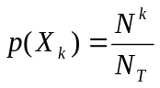
(1)

When K= 0, 1, …., L-1 when N^{k} is the number of pixels in each grey scale that appeared in the image and X, N_{T} is all points in the original.
After getting p(X_{k}), the cumulative density function of PDF is calculated that is
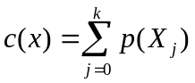

(2)

When X_{k} = x, which k = 0, 1, ….., L-1 and c(X_{L-1}) = 1 is the lowest grey scale and X_{L-1} is the highest grey scale. So that definition function of image transformation f(x) refer to the cumulative density function as

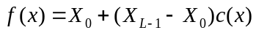
(3)

The output image of histogram equalization,
y ={y(i,j)} can be defined as

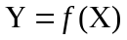
(4)

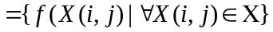
(5)

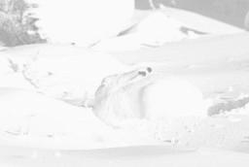
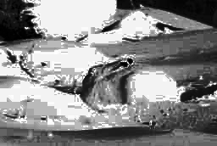

Figures 1(a) Original image of arctic hare Figures 1(b) The output of arctic hare from HE

The above information, it can be said that the HE can significantly transfer the image brightness. For example; Figures 1(a) is the original image of arctic hare and Figures 1(b) is the histogram equalized arctic hare which consists of 256 grey scales. In Figures 1(b), it is found that the HE image darker than the original one, and there are more unnatural in each section. This is the result of HE which changed too much brightness of the image. The most interesting point in HE is that it can transferred the grey scales of the original to new grey scales with increasing the relationship of cumulative density in original and ignored the old grey scale of the original.

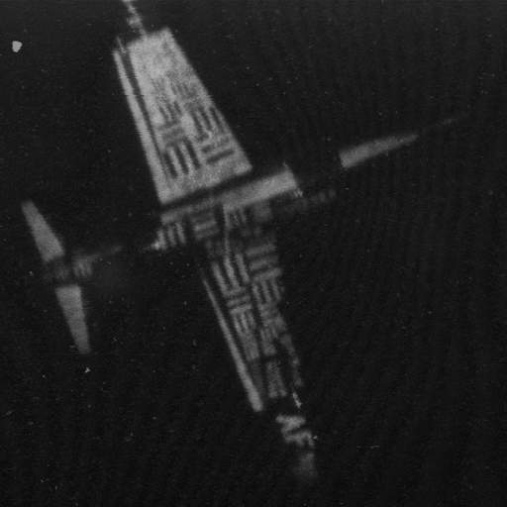
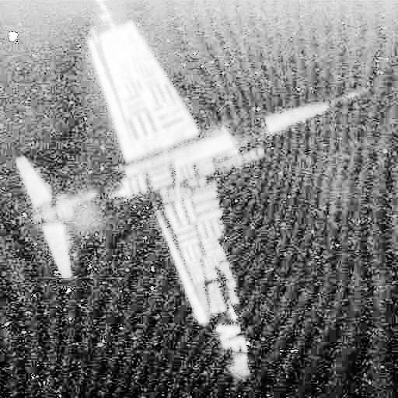

Figures 2(a) Original image of U2 Figures 2(b) The output of U2 from HE

Figures 2(a) is the original of U2 and 2(b) is the HE image which is brighter than the original. A lot of noise in white color occurred on the background and the plane body contrast is reduced which caused the loss of the sharpness. This is because of the limitation of HE, i.e. the mean brightness of the original image may not be used.

3. MINIMUM MEAN BRIGHTNESS ERROR BI-HISTOGRAM EQUALIZATION

We can define the process in the form of a research as follow

- Calculate to find the threshold value from cumulative density.
- Separate the original histogram into groups or sub-histograms according to determined
group which calculated from 1.
- Independently equalize histogram into each group as the separation in 2.
- Calculate AMBE in each group.
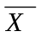
Calculation the mean brightness of image X is which can be defined from

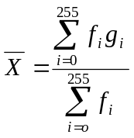

(6)

When
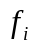
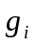is grey scale frequency
is grey scale

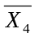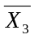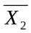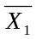 For instance; if histogram is separate into 4 groups, the suitable threshold must be calculated, that is X_{T1}, X_{T2}, and X_{T3} and will get , , and which is the mean of each group.
If N_{T} is all pixels in the image, the pixels in each group will equal N₁, N₂, N₃ and N₄ after the image is divided into 4 groups so that the focus can get from the following formula:

N_{T} = N₁ + N₂ + N₃ + N₄ (7)

Since;

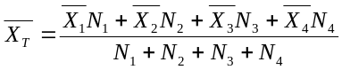
(8)

Or:
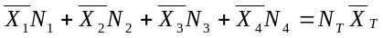
(9)

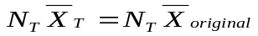
The requirement is

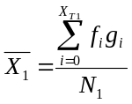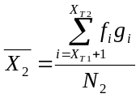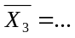

(10)

The result is:

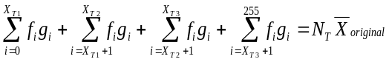
(11)

Require to divide histogram into 4 groups so the simple case is:

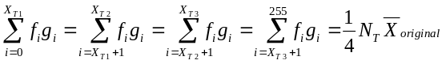
(12)

Due to the difficulty of equation 12 e.g. in the first group if choose X_{T1} is g₅ or g₆ the equation is:

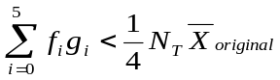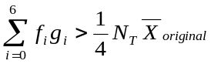
but

So that the pixel must be equalized from some grey scales in g₆ to grey scales g₅ to get the result as equation (12). The numbers of pixels which transferred from g₆ to g₅ is y₁ that can be find out from equation (13) and (14)

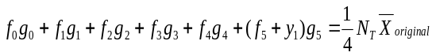
(13)

the result:

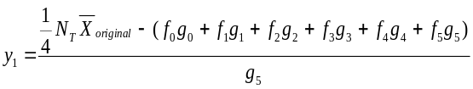

(14)

Nevertheless, the pixels has been transferred, a few errors still occurred which is E₁, e.g.

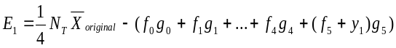
(15)

When we get E₁, it is used in the 2nd group. If X_{T2} is g₂₀, it will be

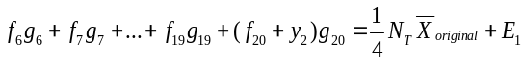
(16)

When some pixels y₂ in grey scale g₂₁ are equalized to join g₂₀, we get y₂ that is:

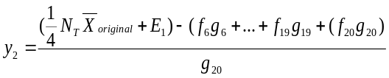
(17)

And the error from the 2nd group is

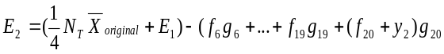
(18)

E₂ is found out as in equation (18). The pixels transformation will continue until before the last group. The last group cannot be transferred because we get all the rest pixels of the image. Therefore, the mean brightness from histogram equalization in each group is E(Y) which is used to calculate the absolute mean brightness error. That is

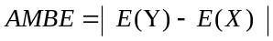(19)

When E(X) is the mean of original image and
E(Y) is the mean of out put image from HE

Histogram of image X [2] before and after equalization (1 group) is illustrated in Figures 4(a). In this picture, histogram is not divided. Picture X is equalized in one group with the lowest and highest grey scales from 0 to 255 which scattered throughout the image.
Histogram separation into 4 groups of picture X in Figures 4(b) is found that it can be calculated threshold at 3 different grey scales i.e. X_{T1}, X_{T2} and X_{T3} sequentially.
The calculated threshold is the point of pixels transformation and error calculation of each group before continuing equalization.
In order to obtain the satisfactory of AMBE, we can recursively divide the original histogram according to its automatically manner by defining the desire of accepted error threshold (ε). The flow chart of the mentioned process can be expressed as the following:

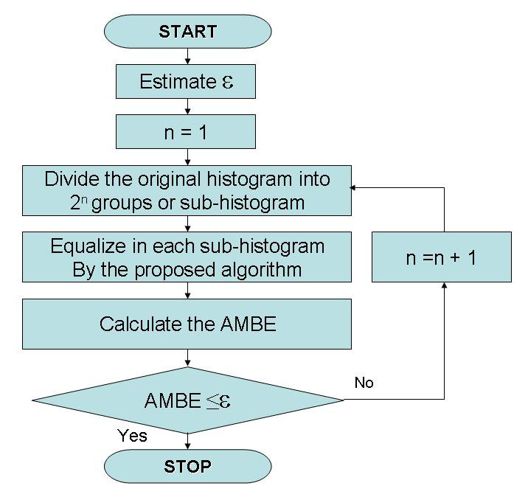

Figure 3 Flow-chart of automatically dividing the original histogram of the image in order to obtain the minimum desired AMBE.

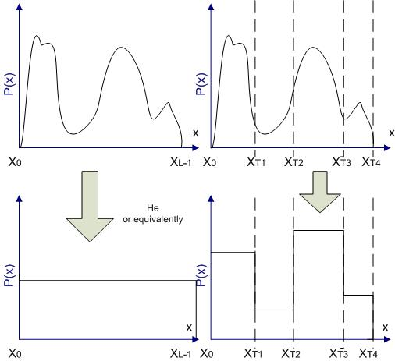

(a) (b)

Figure 4 (a) Original histogram before and after equalization (1 group). (b) For 4 groups.

4. FINDING ANALYSIS

When experiment and compare the out put from 5 pictures (Arctic hare, U2, F16, Clock and Aerial) the absolute mean brightness error (AMBE) is found by the method of the article in [2], [7]. And this research found that AMBE is decreased and able to keep more detail of the picture as well as more natural sharpness and brightness.

Table 1 : Absolute mean brightness error (AMBE)
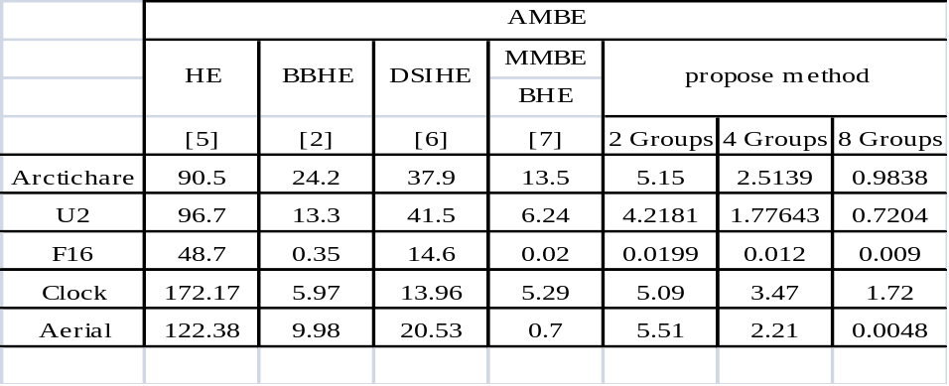

5. CONCLUSION

This research presents the brightness improvement which refers to and adds to the MMBEBHE (Minimum Mean Brightness error Bi-Histogram Equalization). The hub is to separate histogram by calculating to find out the suitable threshold to get the lowest AMBE. This is performed by separating the original image into 2 groups, 4 groups and 8 groups sequentially. The output of this method showed the competence of maintaining the mean brightness mostly the same as the brightness of the original image that illustrated in the table of experiment result.

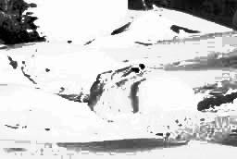
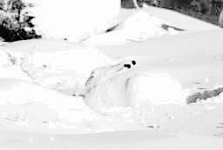

Figures 5(a) Arctic hare (BBHE) Figures 5(b) Arctic hare (MMBEBHE)

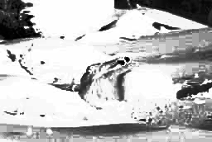
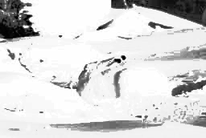

Figures 5(c) Arctic hare (2 Groups) Figures 5(d) Arctic hare (4 Groups)

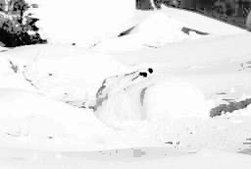

Figures 5(e) Arctic hare (8 Groups)

Figures 5 output of Arctic hare in various methods

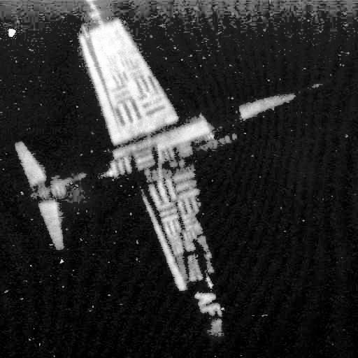
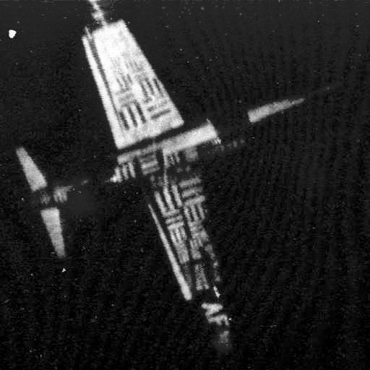

Figures 6(a) U2 (BBHE) Figures 6(b) U2 (MMBEBHE)

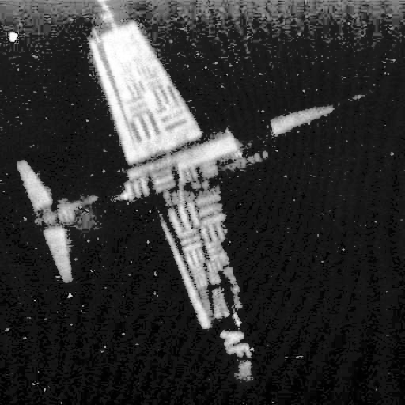
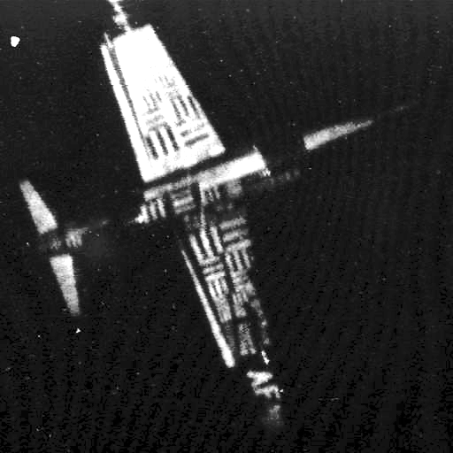

Figures 6(c) U2 (2 Groups) Figures 6(d) U2 (4 Groups)

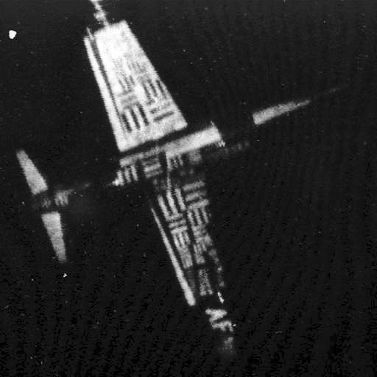

Figures 6(e) U2 (8 Groups)

Figures 6 output of U2 in various methods
The Arctic hare in Figures 5 is a picture with bright background. The result of the performance of 2, 4, and 8 groups has more mean brightness when compare with the original image which is more unnatural contrast.The 4 groups and 8 groups present more natural mean brightness; simultaneously try to keep the continuous reduction of AMBE. Figures 6 is U2 image which is dark background image and more noise in white color can be noticeable in Figures 2(b) due to the increasing of brightness. Obviously, the equalized output of 2 groups and 8 groups, the noise in white color in 1 group decreased and mostly disappeared in 4 groups and 8 groups.

We can also independently apply the proposed algorithm onto composite color image of Fig 7 (a).We can obtain the enhanced color image as show in Fig 7(b)-(d).

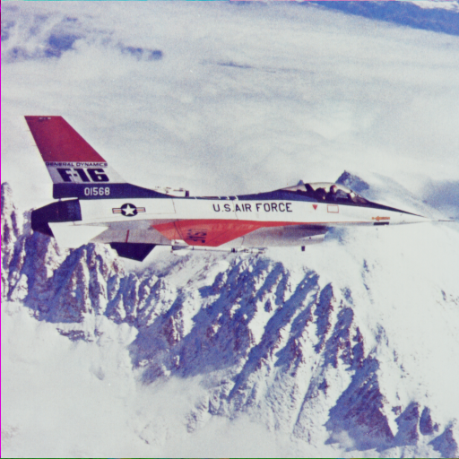
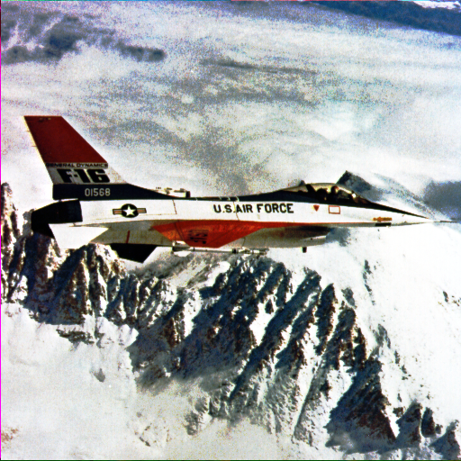

Figures 7(a) Original image of f16 Figures 7(b) divided into 2 groups with
AMBE = 16.5497
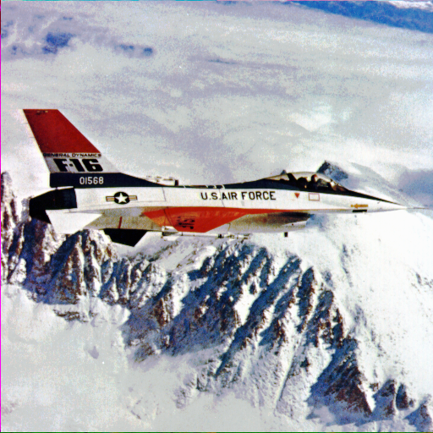
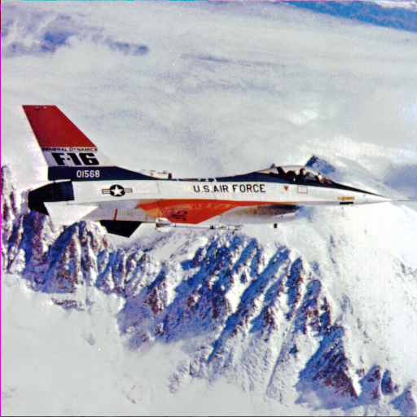

Figures 7(c) Divided into 4 groups with Figures 7(d) Divided into 8 groups with
AMBE = 5.2832 AMBE = 0.9649

Figures 7 Color image of F16

REFERENCES

[1] J.S.Lim, “Two-Dimensional Signal and Image Processing”, Prentice Hall, Englewood
Cliffs, New Jersey, 1990.

[2] Yeong-Taeg Kim, “Contrast Enhancement Using Brightness Preserving Bi-Histogram
Equalization”, IEEE Transactions on Consumer Electronics, February, 1997.

[3] Scott E Umbaugh, “Computer vision and Image Processing”, Prentice Hall : New
Jersey, 1998.

[4] Yu Wan, Qian Chen and Bao-Min Zhang.,”Image Enhancement Based On Equal Area
Dualistic Sub-Image Histogram Equalization Method.” IEEE Transactions Consumer Electronics,February,1999.

[5] Young-tack Kim and Yong-hun Cho, “Image Enhancing Method Using Mean-Separate
Histogram Equalization”, United Stated Patent, Patent No.5,963,665, Oct 5, 1999.

[6] Yu Wan, Qian Chen and Bao-Min Zhang, “Image Enhancement Based on Equal Area
Dualistic Sub-Image Histogram Equalization Method”, IEEE Transactions on Consumer Electronics, vol. 45,no.1,pp. 68-75, Feb. 1999.

[7] Soon-Der Chen, “Minimum Mean Brightness Error Bi-Histogram Equalization in
Contrast Enhancement”, IEEE Transactions on Consumer Electronics, November, 2003.

[8] Soon-Der Chen, “Contrast Enhancement using Recursive Mean-Separate Histogram
Equalization for Scalable Brightness Preservation”, IEEE Transactions on Consumer Electronics, November, 2003.

